**HQL ASSIGNMENT**

1. The number of movies released between 1950 and 1960.

**Query**



**Output**



1. The number of movies having rating more than 4.

**Query**



**Output**



1. The movies whose rating are between 3 and 4.

**Query**



**Output**

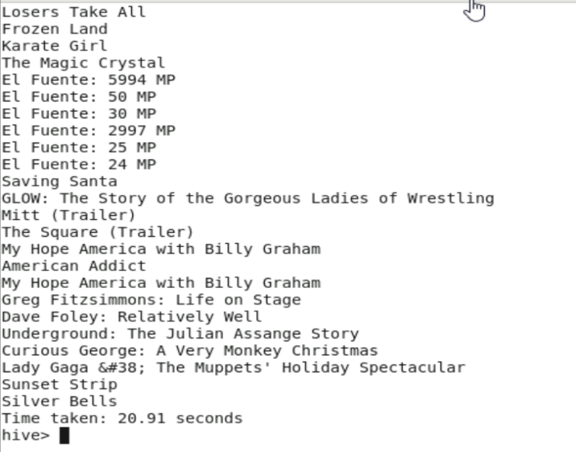

4. The number of movies with duration (reviews) more than 2 hours (7200 second)

**Query  
**

**Output**

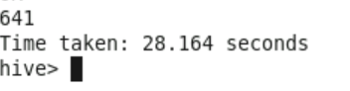

5. The list of years and number of movies released each year.

**Query**



**Output**

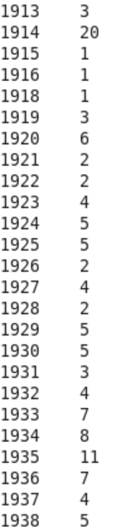 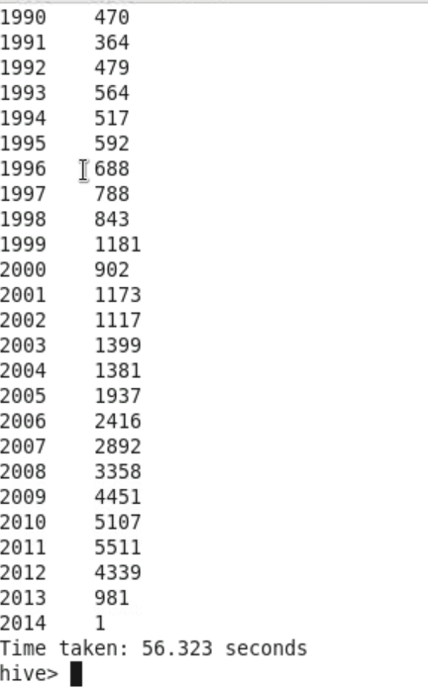

6. Total number of movies in dataset

**Query**



**Output**

